EXPERIMENT 3: Simulation of Energy States of Quantum Dot using NanoHub
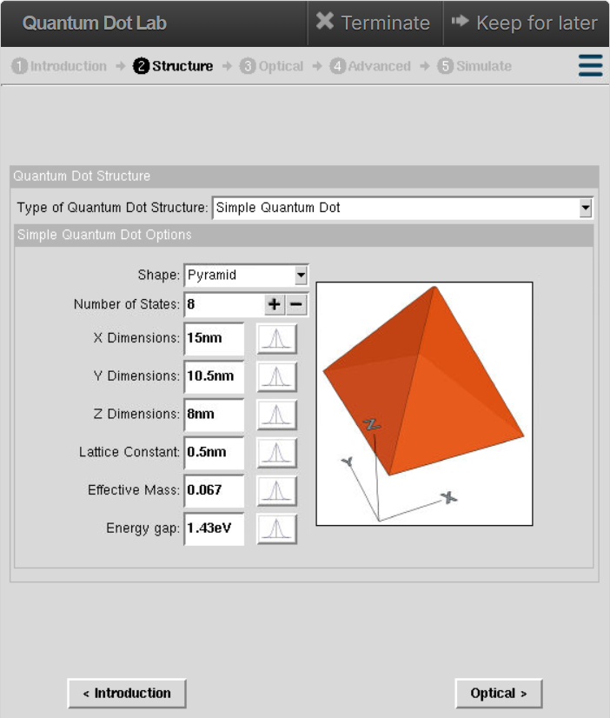

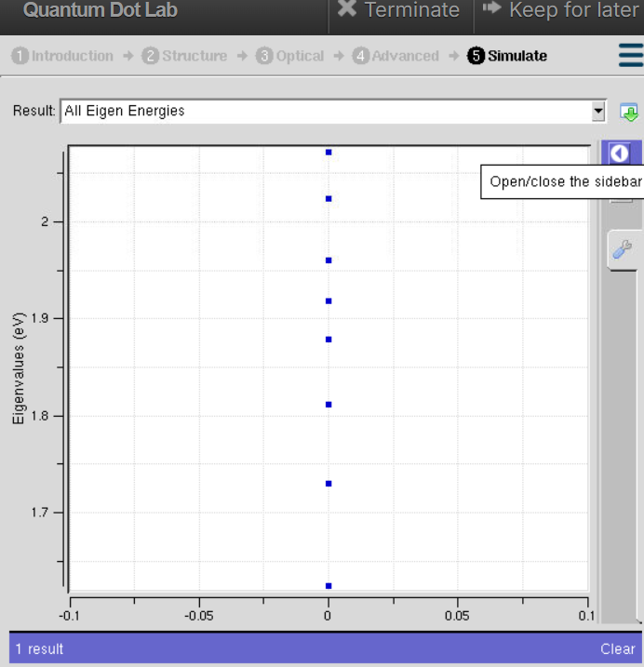

A triangular quantum dot is used to study how the shape of the quantum dot affects the electron energy states. Compared to circular or square quantum dots, a triangular shape provides different electron confinement, resulting in different energy levels.
Case Study 1: Simulate the energy states of cylindrical quantum dots of X=15 nm, Y = 10.5nm and Z = 8 nm.
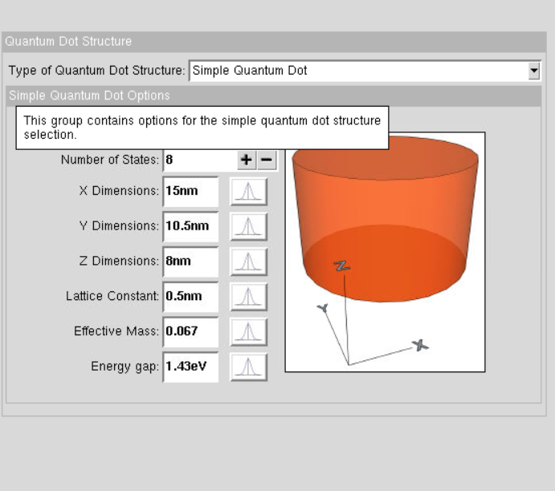

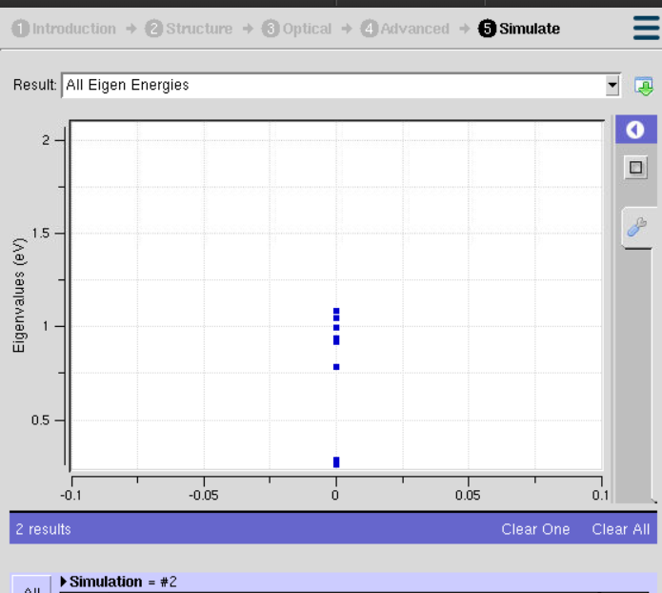

This case study is performed to study the energy states of a cylindrical quantum dot with the given dimensions. The size of the quantum dot determines how strongly electrons are confined, which affects the energy levels

Case Study 2: Simulate the energy states of two layer cuboid quantum dots
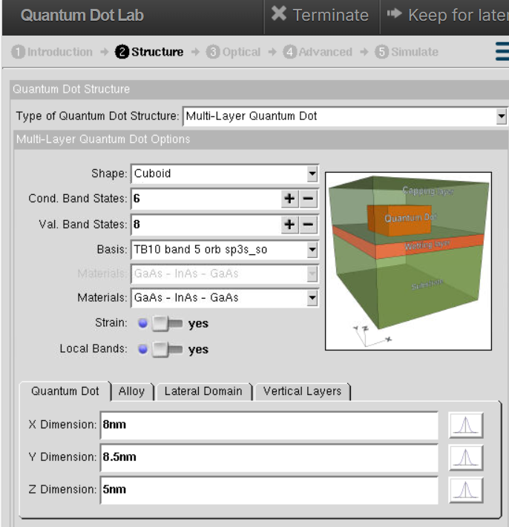

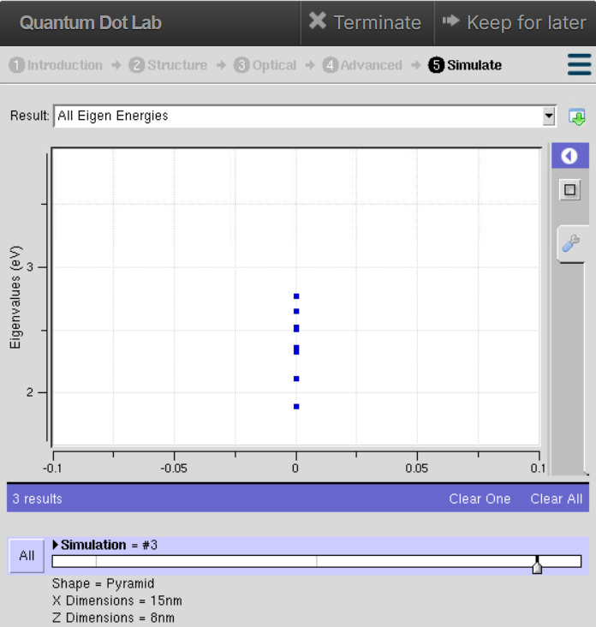

This case study is performed to study how a two-layer cuboid quantum dot affects the electron energy states. The additional layer changes the confinement of electrons, leading to different energy levels compared to a single-layer quantum dot.

